Aspirus Hospital

Portage Health

BCMH

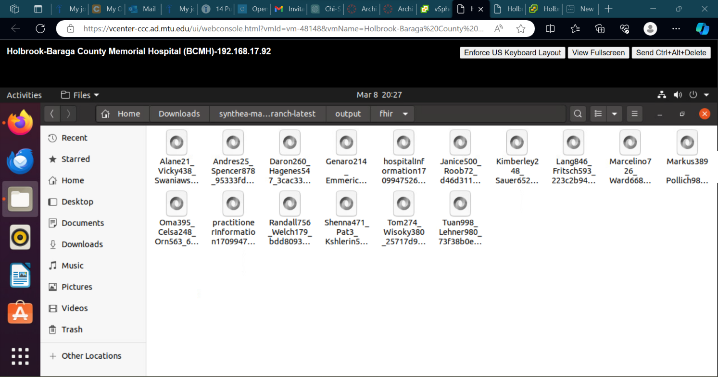

MGH

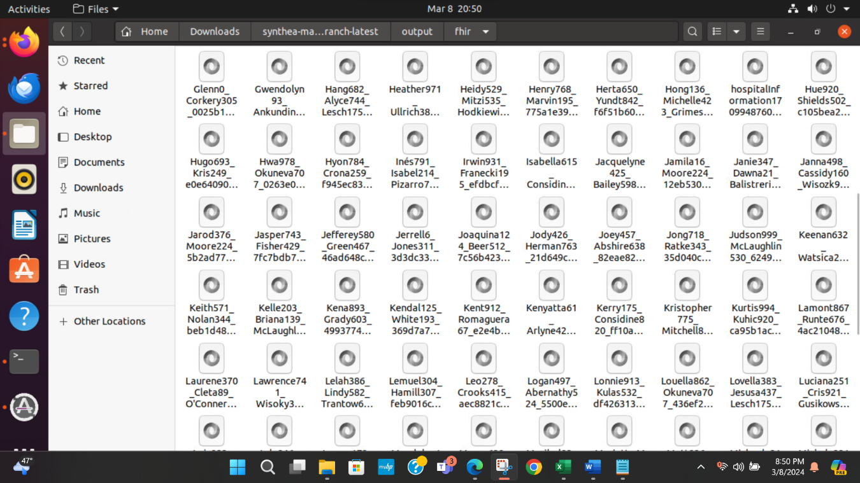

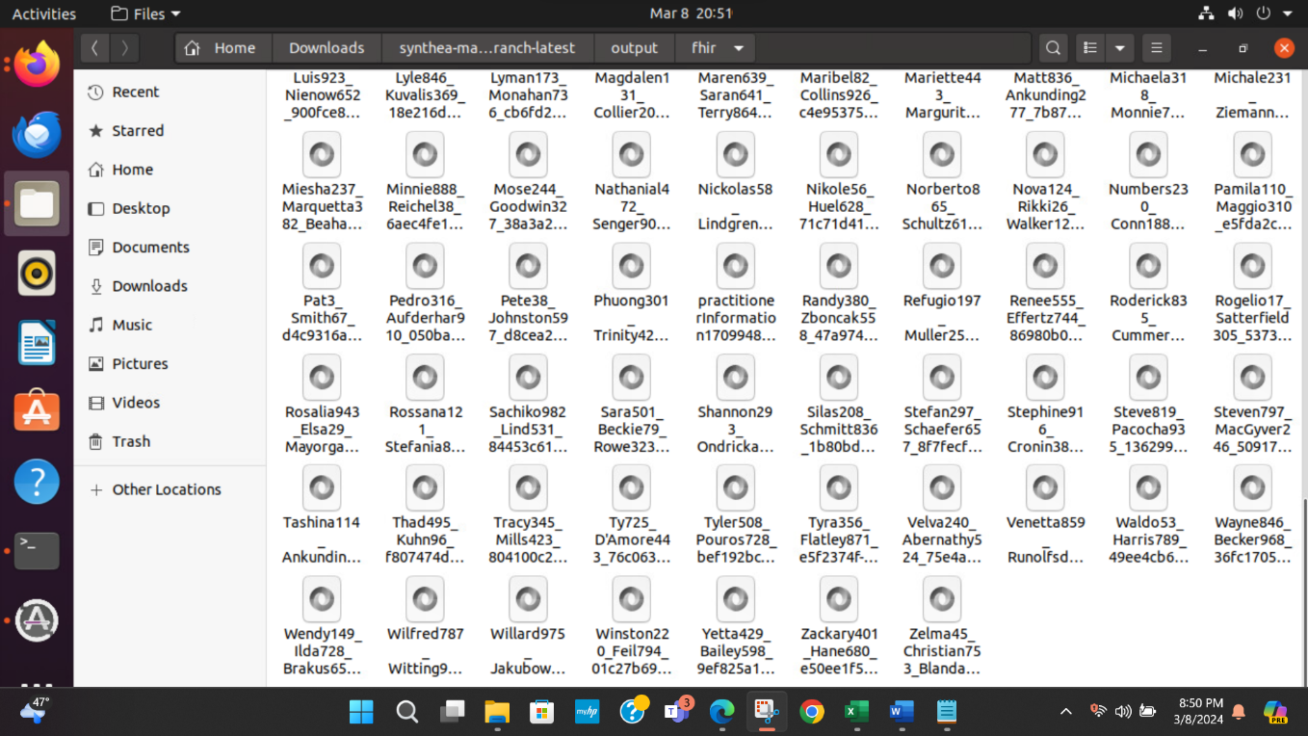

B) Complete the table below (4 points)

|  |  |  |
| --- | --- | --- |
| **Hospital** | **% Used of Total Served**  **Hospital Population** | **Amount of COVID Patients Created** |
| Aspirus | .4% | 20 |
| Portage Health | .6% | 54 |
| BCMH | 2% | 14 |
| MGH | 7% | 140 |

The most challenging part of this assignment was just making sure that I wasn’t missing something in the terminal. Once I realized what had to be done after completing the second hospital, the assignment was pretty easy. I realized what I was doing wrong and just made corrections so I knew what not to do the next time.